H.T No
Regulations:
A15

Sreenidhi Institute of Science and Technology
(An Autonomous Institution)
Code No: 5E517 Date: 25-Jan-2025 (AN)

B.Tech III-Year I- Semester External Examination, January - 2025 (Supplementary)
Theory of Computation (CSE and IT)

Time: 3 Hours Max.Marks:75 Note: a) No additional answer sheets will be provided.
b) All sub-parts of a question must be answered at one place only, otherwise it will not be valued.
c) Missing data can be assumed suitably.

Bloom's Cognitive Levels of Learning (BCLL)
Remember | L1 | Apply | L3 | Evaluate | L5
Understand | L2 | Analyze | L4 | Create | L6

Part - A Max.Marks:25

Answer all QUESTIONS.
 |  | BCLL | CO(s) | Marks
1 | Explain transition diagram& transition table with an example. | L1 | CO1 | [2M]
2 | Compare DFA and NFA. | L2 | CO2 | [2M]
3 | What is derivation? Explain Left Most Derivation & Right Most Derivation. | L1 | CO3 | [2M]
4 | State pumping lemma for Context Free Languages (CFG). | L2 | CO4 | [2M]
5 | Explain counter machine. | L2 | CO5 | [2M]
6 | Define P, NP problems with an example. | L1 | CO6 | [3M]
7 | Define Moore and Melay Machines. | L2 | CO1 | [3M]
8 | Define Regular language and Regular Expression and give an example. | L1 | CO4 | [3M]
9 | Define Linear Bounded Automate formally? | L1 | CO5 | [3M]
10 | Why normal forms are important? When a grammar is said to be in Chomsky normal form? | L3 | CO2 | [3M]

Part – B Max.Marks:50
ANSWER ANY FIVE QUESTIONS. EACH QUESTION CARRIES 10 MARKS.

 |  |  | BCLL | CO(s) | Marks
11. | a) | Design DFA that accepts all the strings containing odd numbers of 0’s & even number of 1’s. | L5 | CO1 | [5M]
 | b) | Design DFA that accepts all the strings containing “100” as substring over an alphabet {0,1}. | L5 | CO1 | [5M]
12. | a) | Convert the following NFA to DFA.  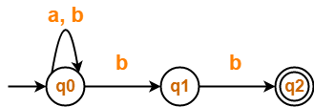 | L3 | CO2 | [5M]
 | b) | Minimize the following DFA  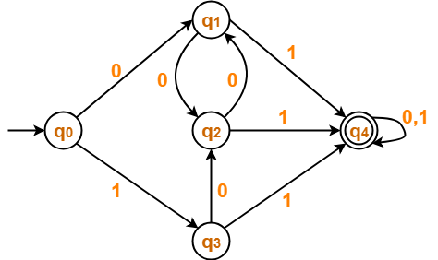 | L3 | CO2 | [5M]
13. | a) | Construct a regular expression for a given finite automata.  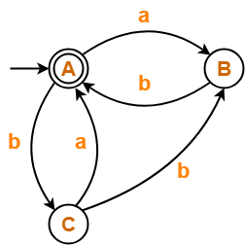 | L3 | CO3 | [5M]
 | b) | Construct DFA for the given Regular Grammar  S ->0A/1B/0/1  - ->0S/1B/1  B-->0A/1S | L6 | CO3 | [5M]
14. | a) | Convert the following CFG to GNF form  S->AA| 0  A->SS| 1 | L4 | CO4 | [5M]
 | b) | Construct a PDA to accept the language  L= {WW^{R} |W ∈(0+1)*} by a final state. Also show the moves made by the PDA for the string "000111" | L5 | CO4 | [5M]
15. | a) | What is Turing Machine? Explain different types of Turing Machines? | L2 | CO5 | [5M]
 | b) | Design Turing Machine (TM) to accept the language L= {WWR | W ∈ (0+1)*}. Also show the moves made by the TM for the string "abba" | L4 | CO5 | [5M]
16. | a) | Explain Chomsky’s Hierarchy of Languages with appropriate examples. | L2 | CO6 | [5M]
 | b) | Define Post's Correspondence Problem (PCP)?  For a given set A = (b, bab3, ba) and B = (b3, ba, a). Find the solution. | L3 | CO6 | [5M]
17. | a) | Design Finite Automata to accept all string that does not contains 3 consecutive zeros, over an alphabet {0,1}. | L2 | CO1 | [4M]
 | b) | Write about acceptance of languages. | L3 | CO2 | [3M]
 | c) | Design FA for the given Regular Expression R= (0+1)*00(0+1)*. | L4 | CO3 | [3M]
18. | a) | Explain the process of minimization of context free grammar. | L1 | CO4 | [4M]
 | b) | What is computable function? Give an example. | L1 | CO5 | [3M]
 | c) | What is Turing reducibility and why it is important? | L2 | CO6 | [3M]

-- 00 -- 00 –

